 | Name of Teaching Staff :- |  | Prof. Bhushan |  |  | 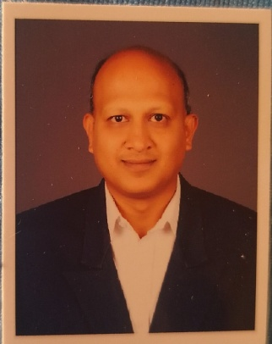
 | Designation :- |  | Assistant Professor
 | Department :- |  | Artificial Intelligence & Data Science
 | Date of Joining the Institution:- |  | 01-10-2022
 | Qualifications with Class/Grade:- |  | UG | PG |  | Ph. D
 |  |  | BE (CS) | M.Tech.(CSE) |  | -----
 | Total Experience in Years:- |  | Teaching | Industry |  | ResearchPh.D
 |  |  | 10 years | ----- |  | ----
Papers Published in Journals:- |  | National |  |  | International
 |  | 00 |  |  | 00
Conference Papers Published:- |  | National |  |  | International
 |  | 00 |  |  | 00
Ph.D. Guide? Give field University:- |  | Field |  |  | University
 |  | ----- |  |  | -----
Ph.Ds. / Masters Level Projects Guided:- |  | Ph. D. |  |  | Masters Level
 |  | ----- |  |  | -----
Books published / IPRs/ Patents:- |  | -----
Professional Memberships:- |  | -----
Consultancy Activities:- |  | -----
Awards:- |  | -----
Grants Fetched:- |  | -----
Interaction with Professional :- Institutions |  | -----

