

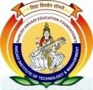
Suresh Angadi Education Foundation’s

ANGADI INSTITUTE OF TECHNOLOGY AND MANAGEMENT
Savagaon Road, Belagavi – 590 009.
ved by AICTE, New Delhi &Affiliated to Visvesvaraya Technological University, Belagavi)
( Appro
Accredited by NAAC
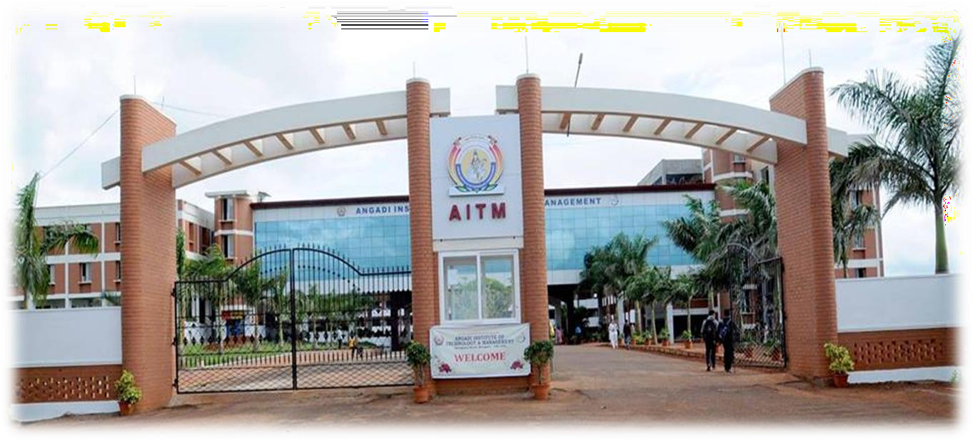

DRISHTI
E- Newsletter

Department of Artificial Intelligence & Data Science
E – Newsletter -2026-27
Volume:1, Issue 4

Message from: Principal & Director

Dr. Anand Deshpande
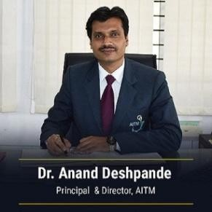
An Institute is assessed on the basis of the Academic ambiance and outcome of the system in terms of performance and
achievements of the students and staff in teaching-learning, research, innovation, Placements, and results. AITM has been known for its Academic credentials coupled with holistic growth in all directions. The new generation of competent minds must imbibe knowledge and practically they should comprehend the art of balancing brilliant technical, managerial communication, and interpersonal skills, nest. The Institute has achieved a series of milestones with the help of brilliant students, dedicated staff, and encouraging Management. We promise a wonderful experience of rich Academic and Excellent facilities coupled with professional practices and blended with an affectionate concern for our Students.
Message from: HOD

Prof. Sagar Birje

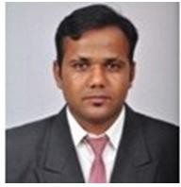
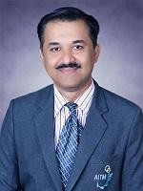
Welcome to the Department of Artificial Intelligence and Data Science. AI and DS is the skill of the century and has
had a massive impact on the society. AI and DS have seen enormous progress and
significant breakthrough innovations in practically every field over the last decade. Keeping this in mind, the AI and DS Department was established in the year 2020 with the aim of providing leadership in the field of AI & DS Engineering with an intake of 60 students. The Department is focused on delivering innovative and high-quality technical education in the field of Artificial Intelligence and Data Science.

Institute Vision and Misssion
Vision:
To become a premier institute committed to academic excellence and global competence for the holistic development of students.
Mission:
M1: Develop competent human resources, adopt outcome-based education (OBE) and Implement cognitive assessment of students.
M2: Inculcate the traits of global competencies (such as domain expertise, Accountability, ethics, problem solving ability, communication skills, leadership Qualities and life-long learning) amongst the students.
M3: Nurture and train our students to have domain knowledge, develop the qualities of global professionals and to have social consciousness for holistic development.

Department Vision and Mission

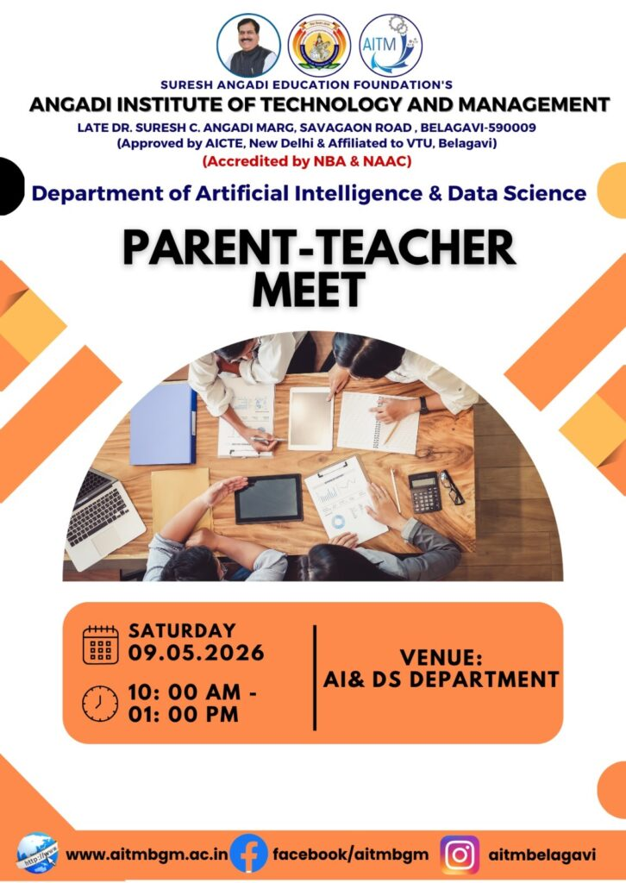

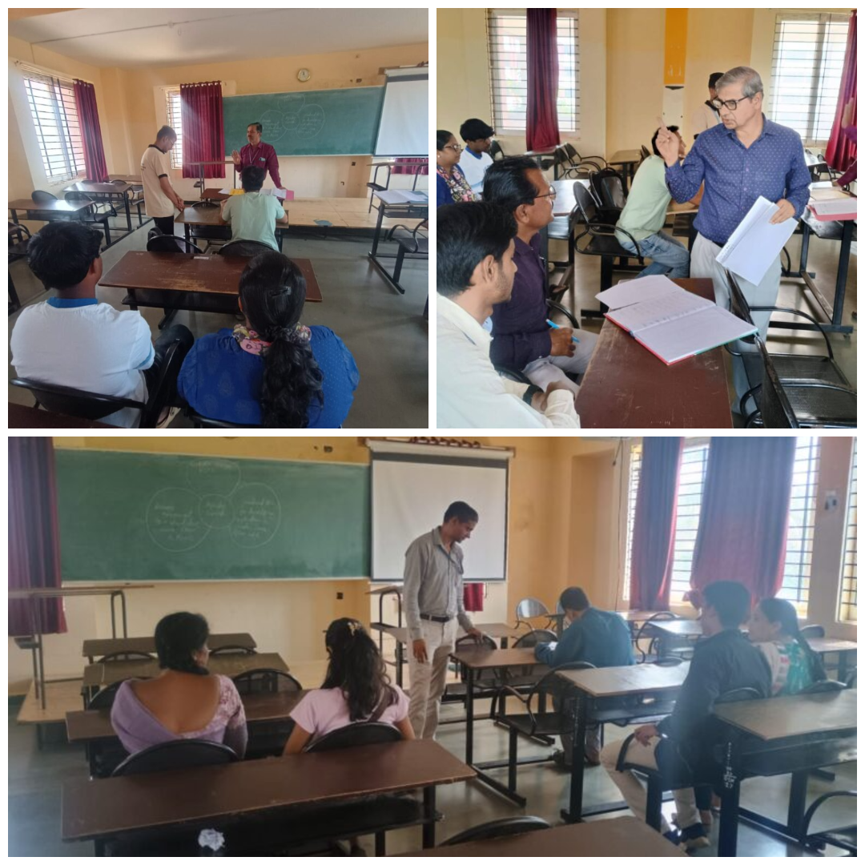

Vision:
To deliver a quality and responsive education in the field of artificial intelligence and data science emphasizing professional skills to face global challenges in the evolving IT paradigm. Mission:
M1: Leverage multiple pedagogical approaches to impart knowledge on the
Department Activities.
Parents-Teacher Meeting
The Department of Artificial Intelligence and Data Science (AI & DS), Angadi Institute of Technology and Management (AITM), successfully conducted the Parents-Teacher Meeting on May 09, 2026.
The session began with a warm welcome by Prof. Sagar Birje, Head of the Department, who highlighted the department’s vision, mission, and ongoing academic initiatives. The meeting showcased the remarkable achievements of students and faculty members in hackathons, technical competitions, research publications, and various co-curricular activities.
Faculty members interacted with parents and discussed the academic performance of students, emphasizing both strengths and areas for improvement. Information regarding placement activities, internship opportunities, skill development programs, and industry collaborations was also shared to support students’ career growth and future opportunities.
The meeting provided a valuable platform for open interaction between parents and faculty members, encouraging constructive feedback and collaborative efforts towards the holistic development of students.

current and emerging AI technologies.
M2: Develop an inclusive and holistic ambiance that bolsters problem solving, cognitive abilities and critical thinking.
M3: Enable students to develop trust worthiness, team spirit, understanding law-of-the-land, social behavior to be a global stake holder

Expert Talk: Exploring the Future of Technology at AITM

The Department of Artificial Intelligence & Data Science (AI & DS) organized an insightful session on “Emerging Technologies: AI, Machine Learning & the Future of Software Engineering” on 07/05/2026. The session was delivered by Mohammed Shaheed R Maniyar, Founder of AZDeploy Academy and a Senior Full Stack Developer with over 8 years of industry experience. The session provided students with a clear understanding of the latest advancements in Artificial Intelligence, Machine Learning, and Generative AI, along with their real-world applications and emerging career opportunities. Students also gained valuable insights into how these technologies are transforming the software industry and the essential skills required to stay relevant and succeed in today’s competitive job market. The session was highly informative and inspired students to explore future technologies and industry trends
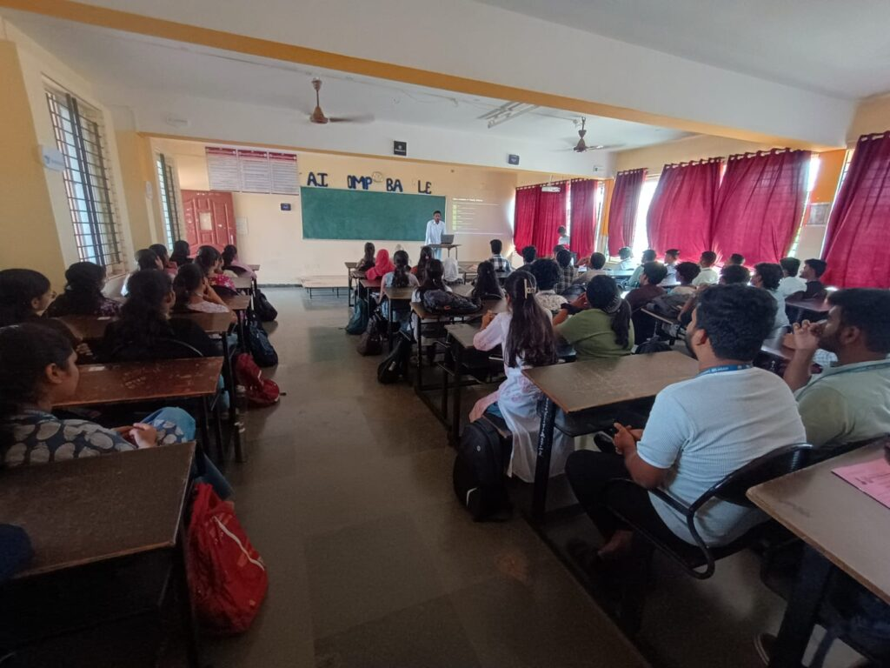

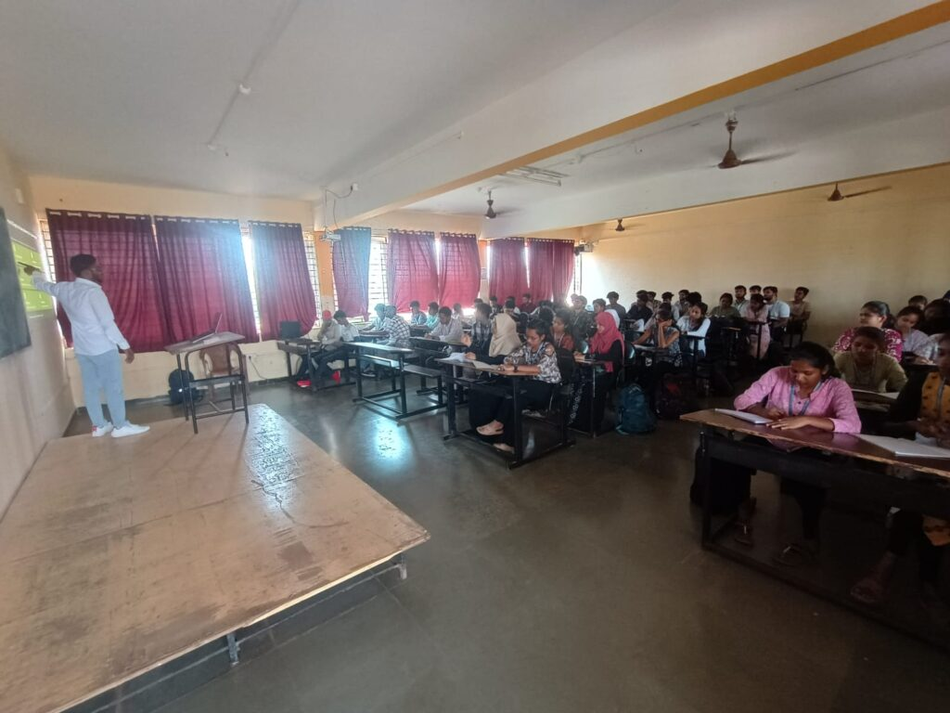

- Educational Visit to DEFTECH Bharat 2026 by 4th Semester AI & DS Students

- The 4th Semester students of the Department of Artificial Intelligence and Data Science, Angadi Institute of Technology & Management, Belagavi, participated in an educational visit to DEFTECH Bharat 2026 at Bengaluru on 21 May 2026. The visit was organized to provide students with practical exposure to emerging technologies and industrial advancements in the fields of defence technology, artificial intelligence, aerospace, and advanced engineering systems.

During the visit, students explored various technology exhibits, observed innovative defence solutions, and interacted with industry professionals to understand real-world applications of Artificial Intelligence and emerging technologies. The students gained insights into cutting-edge developments in autonomous systems, cybersecurity, defence manufacturing, and next-generation technological innovations.
The educational visit aimed to bridge the gap between classroom learning and industry practices while encouraging students toward innovation, research, and skill development. Faculty members accompanying the students emphasized the importance of industrial exposure in enhancing technical knowledge and preparing students for future career opportunities.

The visit concluded successfully with students gaining valuable learning experiences and exposure to advancements shaping the future of technology.

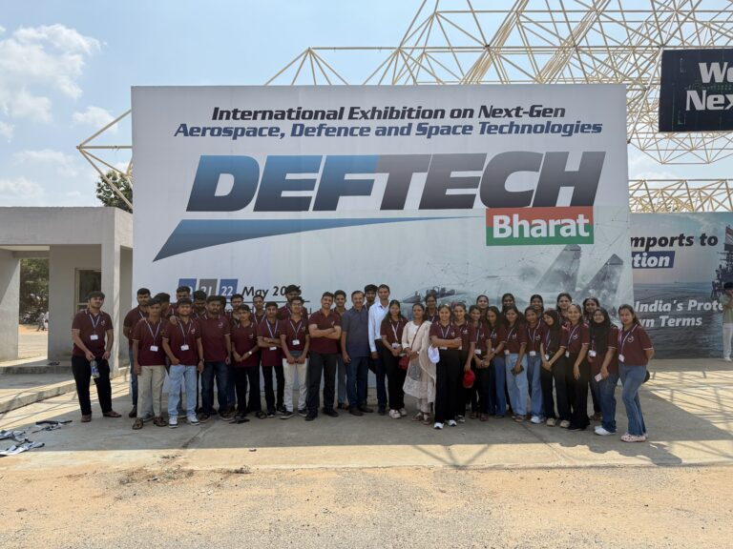

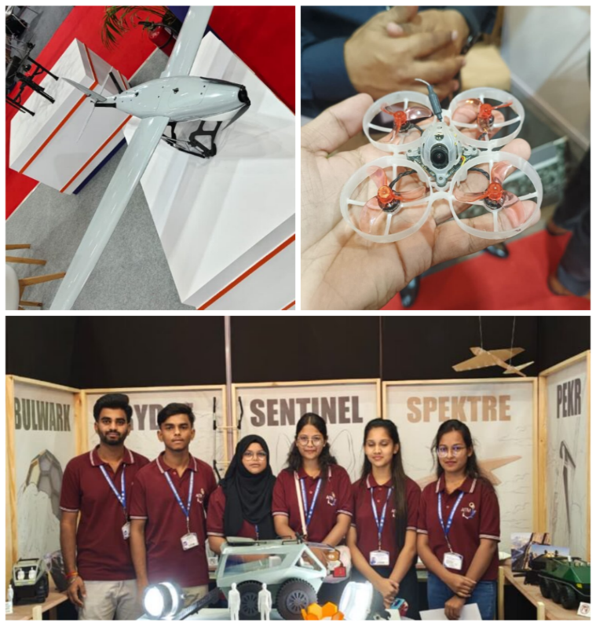

Editorial Team
Chief Editor
Prof. Sagar Birje, HOD
Department of Artificial Intelligence and Data Science
Members
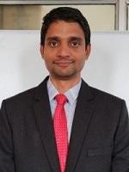 | Prof. Chetan S. Patil  Assistant Professor, Department of Artificial Intelligence and Data Science
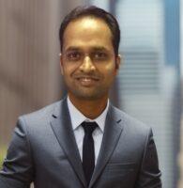 | Prof. Vaibhav Chavan Assistant Professor Department of Artificial Intelligence and Data Science
Student Coordinators
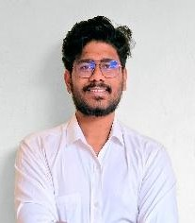 | Mr. Anish Inamadar  Student Coordinator Department of Artificial Intelligence and Data Sceince
 | Miss. Aishwaraya Byati Student Coordinator Department of Artificial Intelligence and Data Sceince

About the Department
The Department of Artificial Intelligence and Data Science at AITM, Belagavi, was established in 2020, marking the beginning of our commitment to delivering exceptional education in Artificial Intelligence and Data Science.

